Neural Networks and Deep Learning

ASSIGNMENT-6

Question 1

* Added 5 Hidden Dense Layers to the given model.

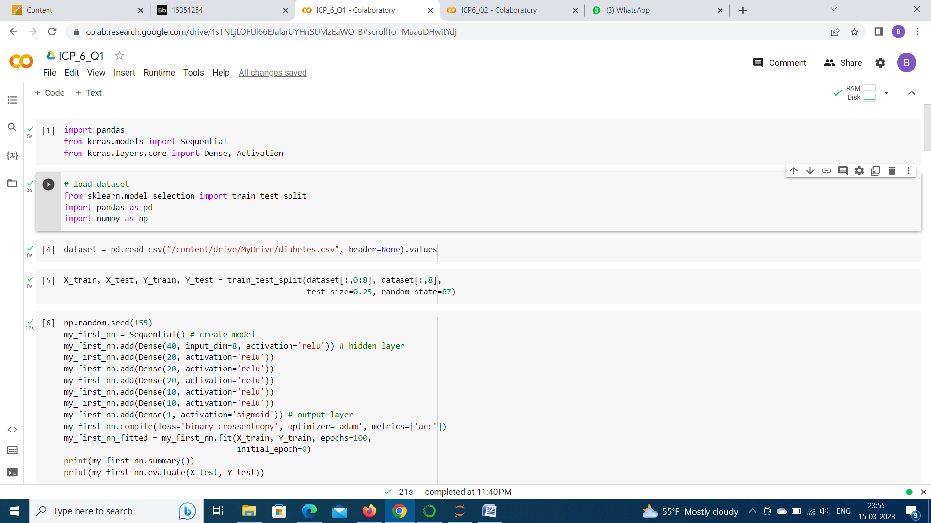

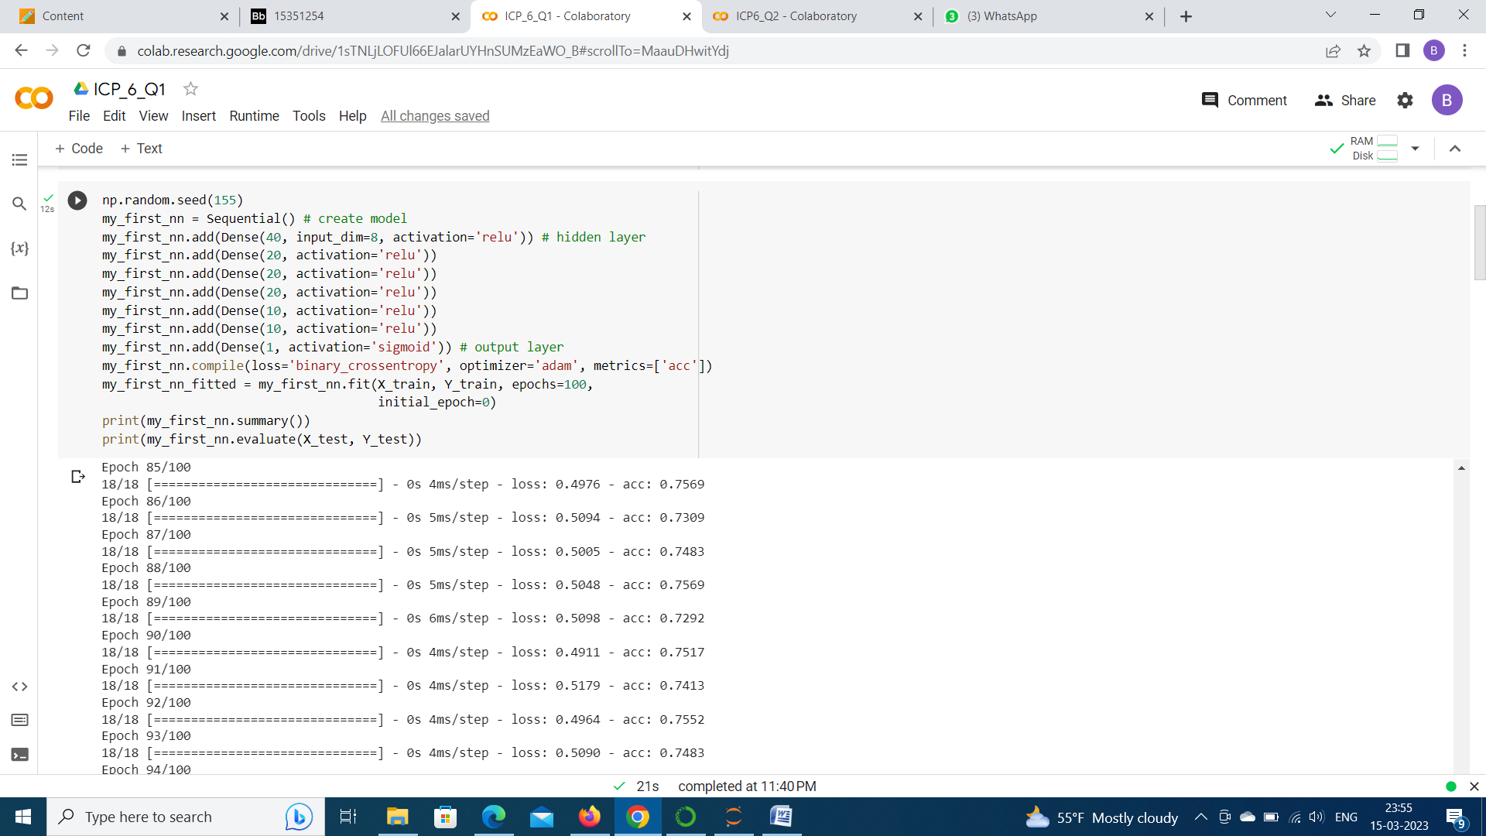

The Accuracy of the model has increased from 64% to 70%.

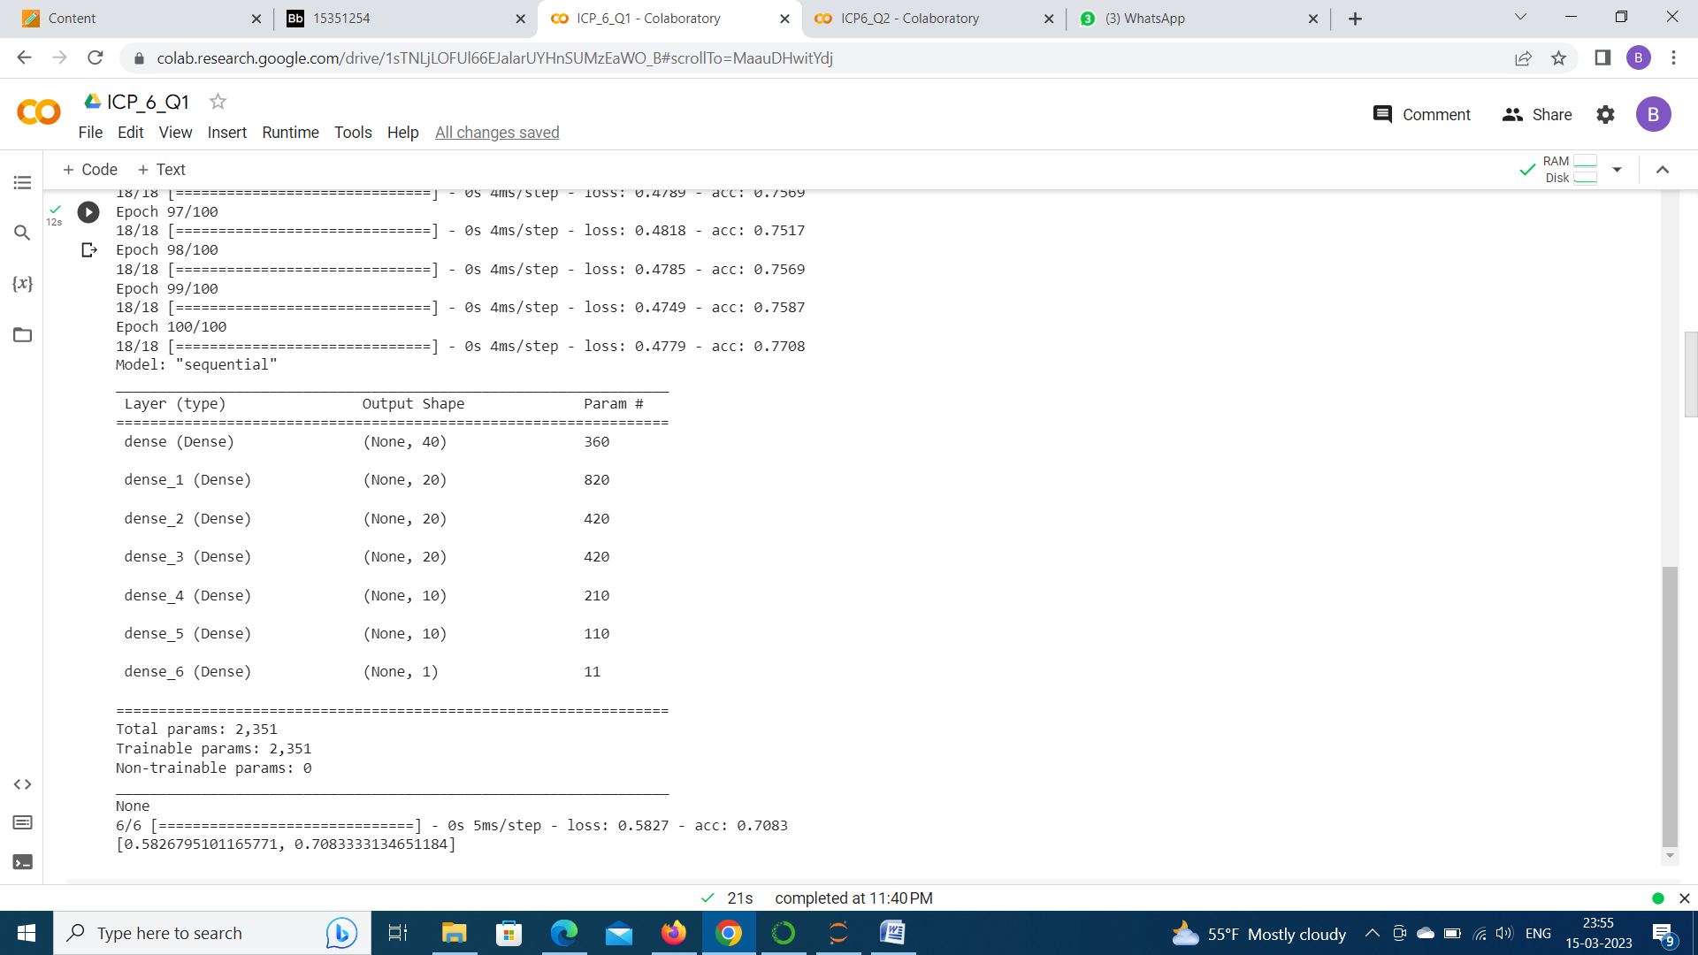

The Dataset is changed to Breast Cancer Dataset and made some changes to the model.

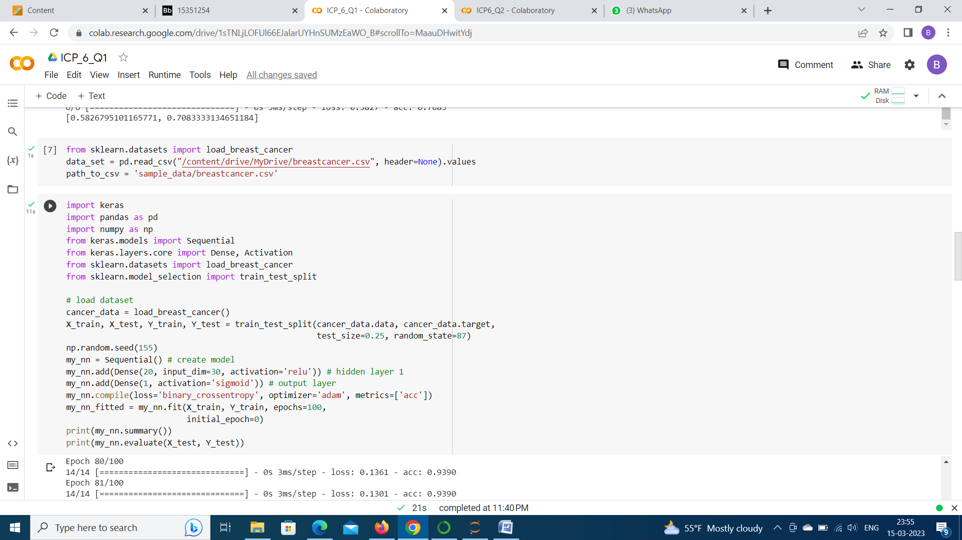

The Accuracy we got for the Breast cancer dataset is 93.66% and the loss is 24.52%.

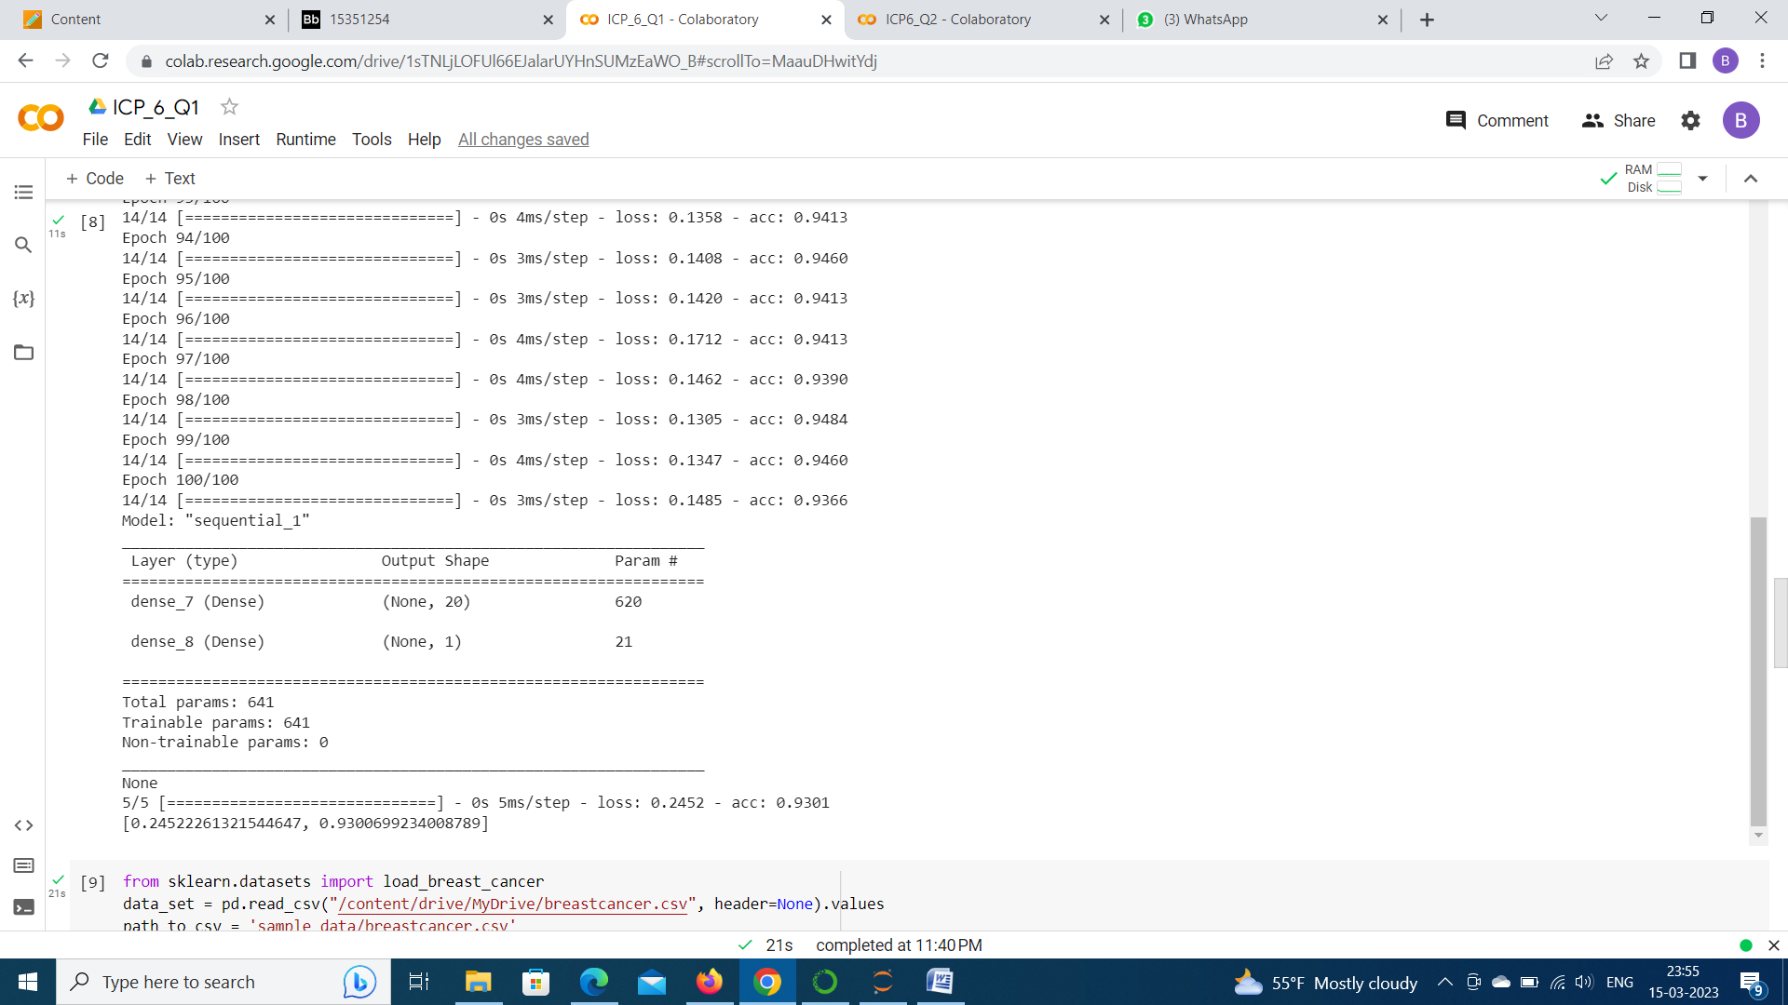

Normalized the data using standardscaler ,before feeding it to the model and observed the accuracy. The accuracy is decresed to 90%.

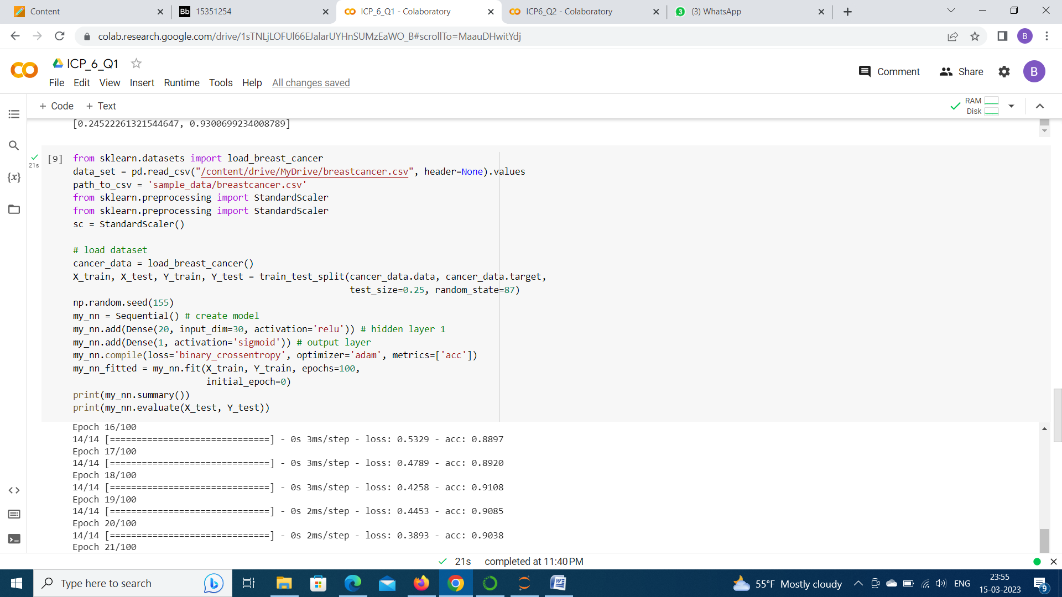

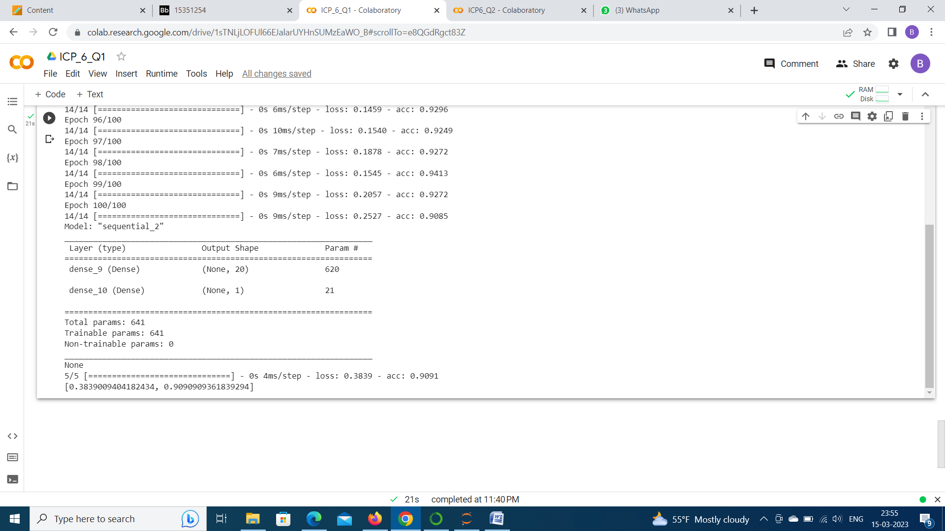

Question 2

Executed the given source code and got the accuracy which is 98.2% and loss which is 00.7%

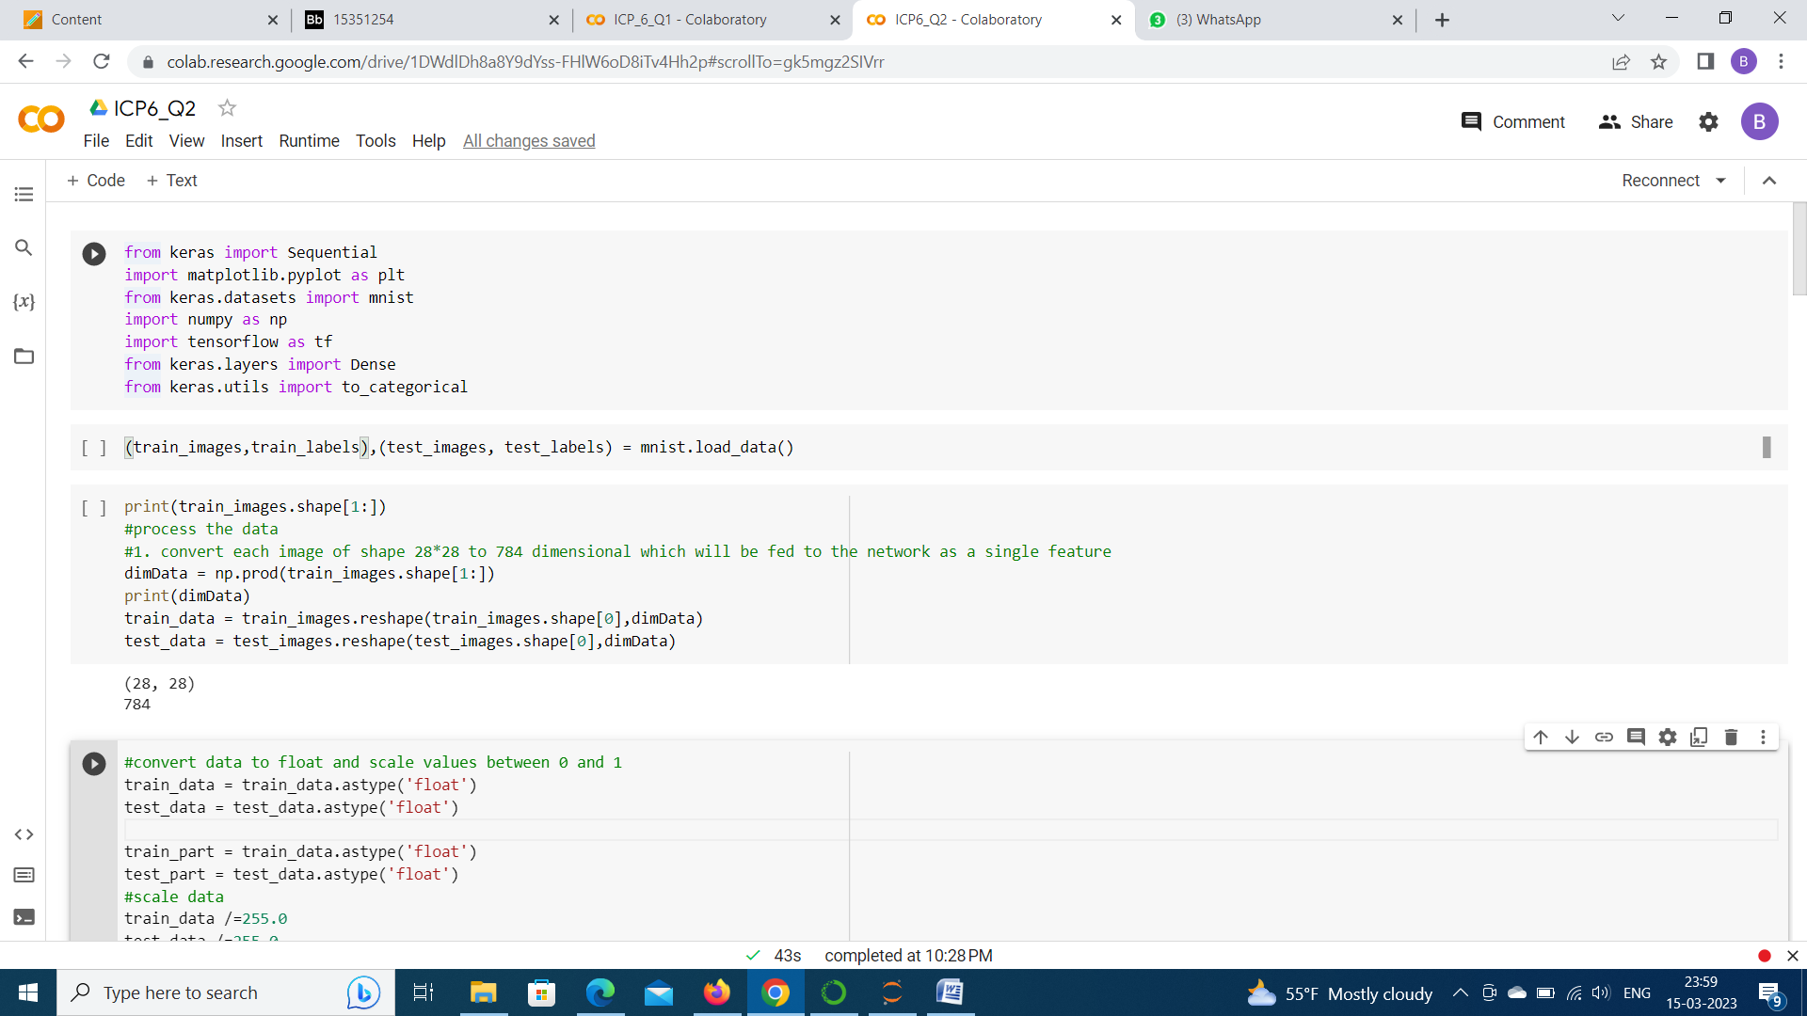

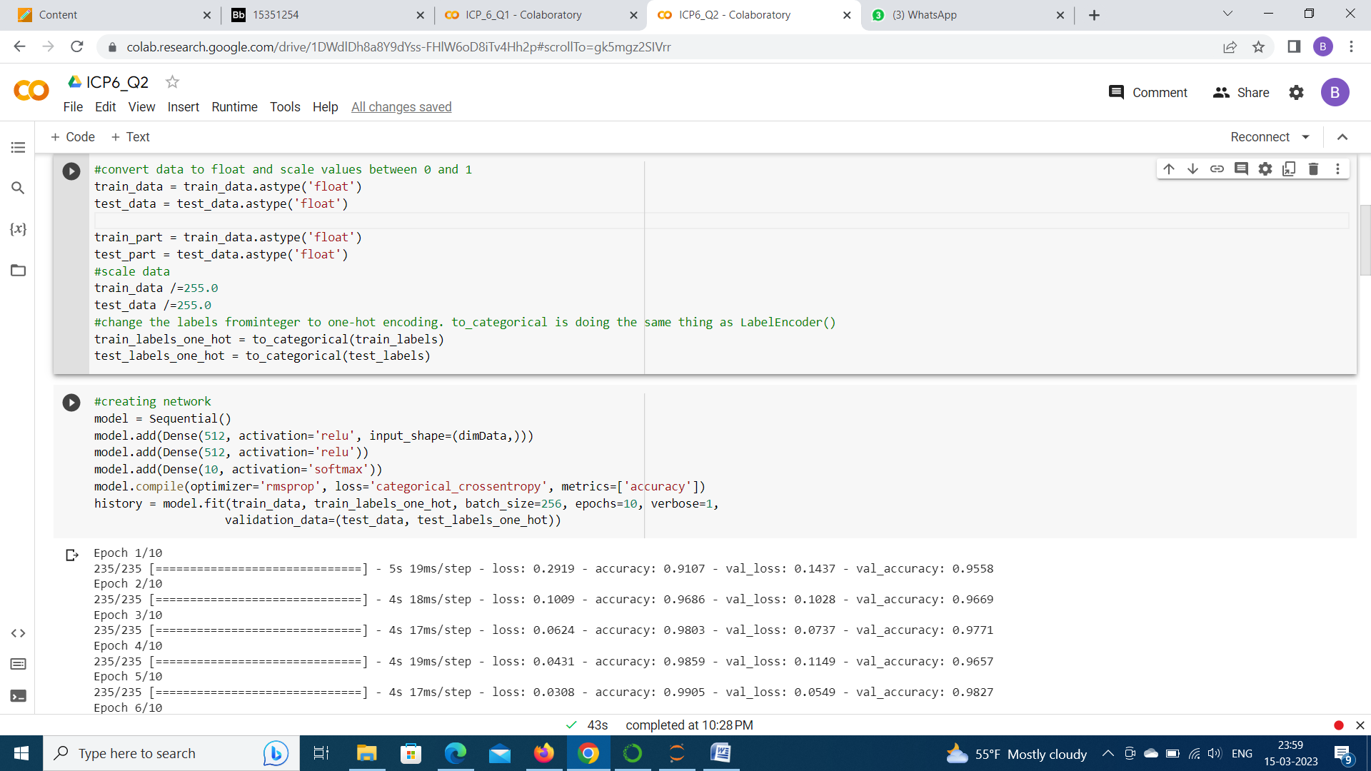

Plotted the graph between the loss of training data and validation data

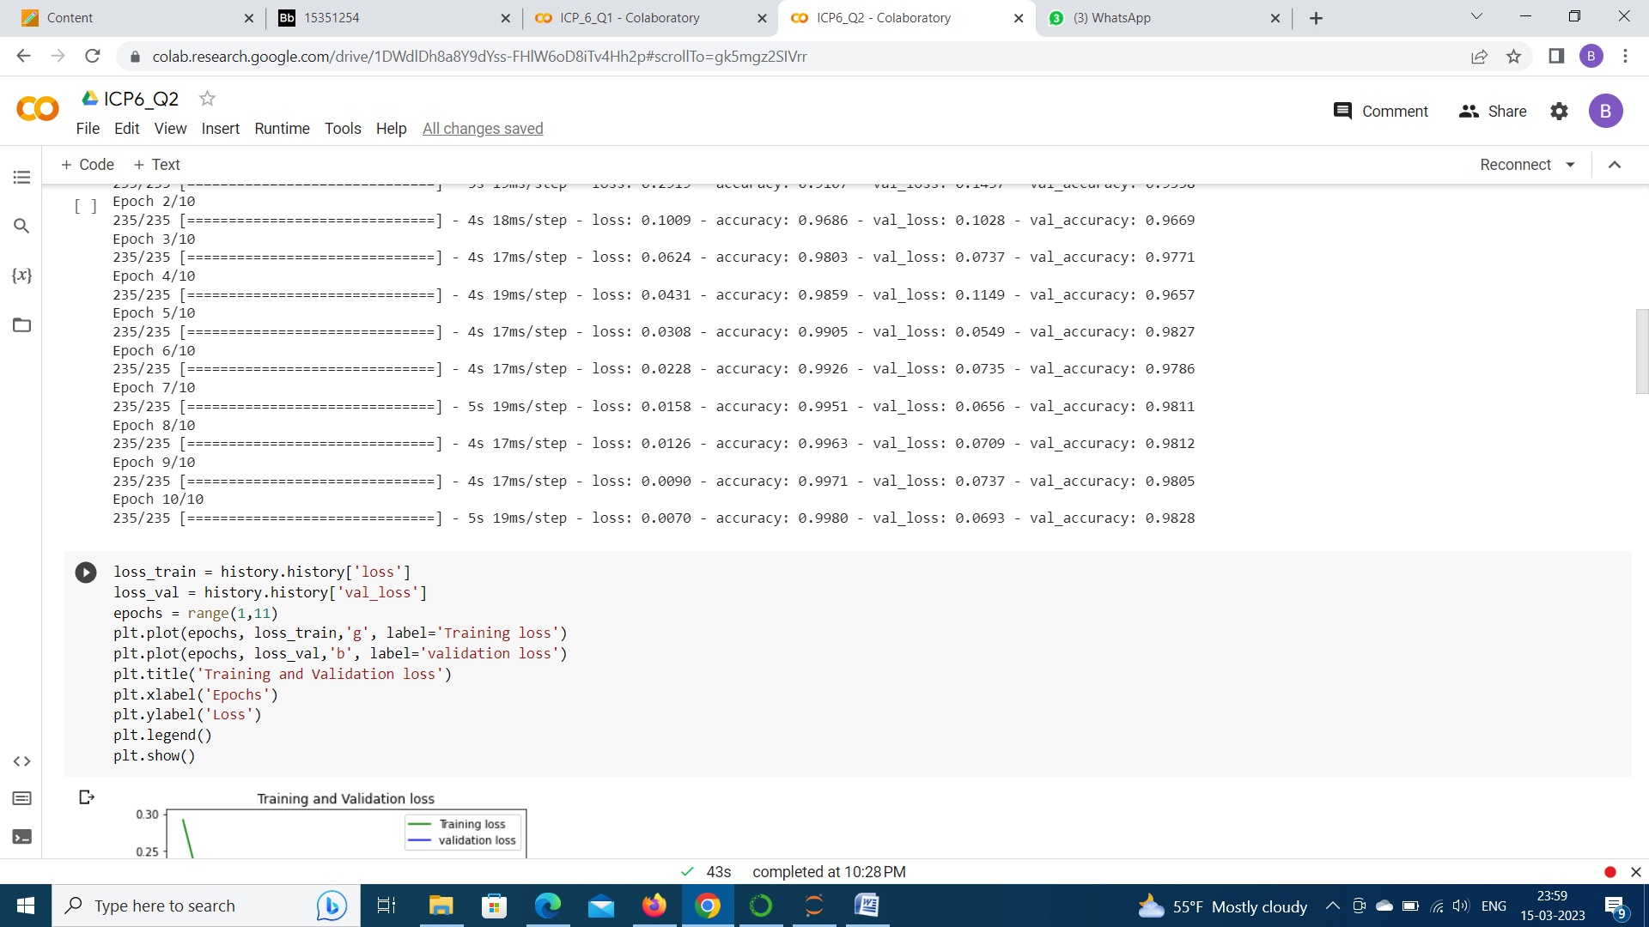

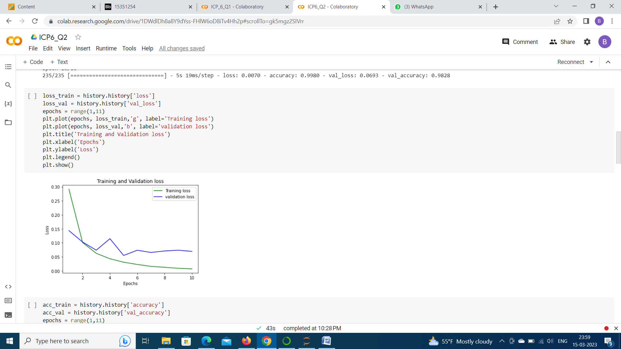

Plotted the graph between the accuracy of training data and Validation data.

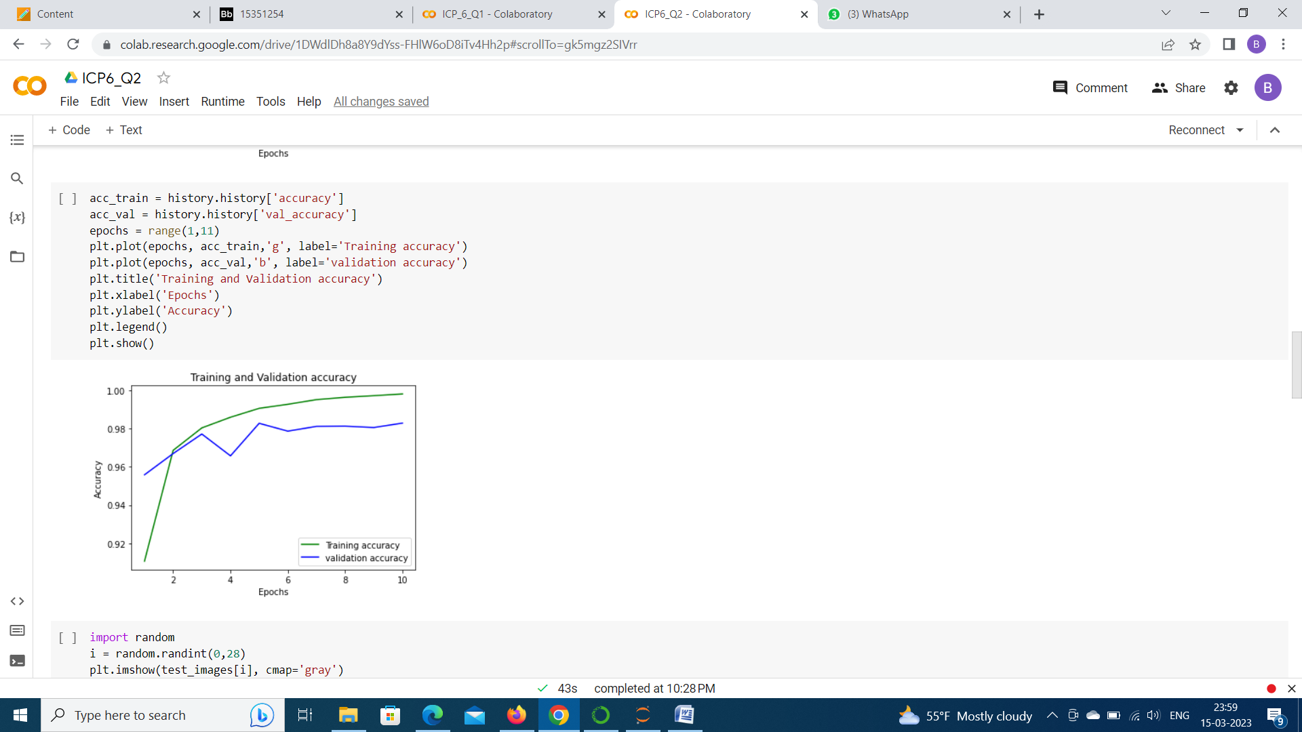

Displayed the image of one input digit, performed inferenceing and predicted the output.

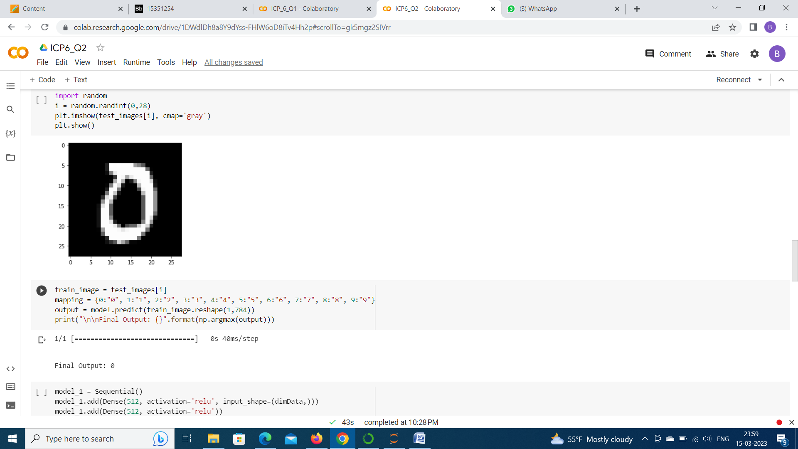

Numbers of Input layers are increased and activation is changed to ‘tanh’ and ‘sigmoid’.

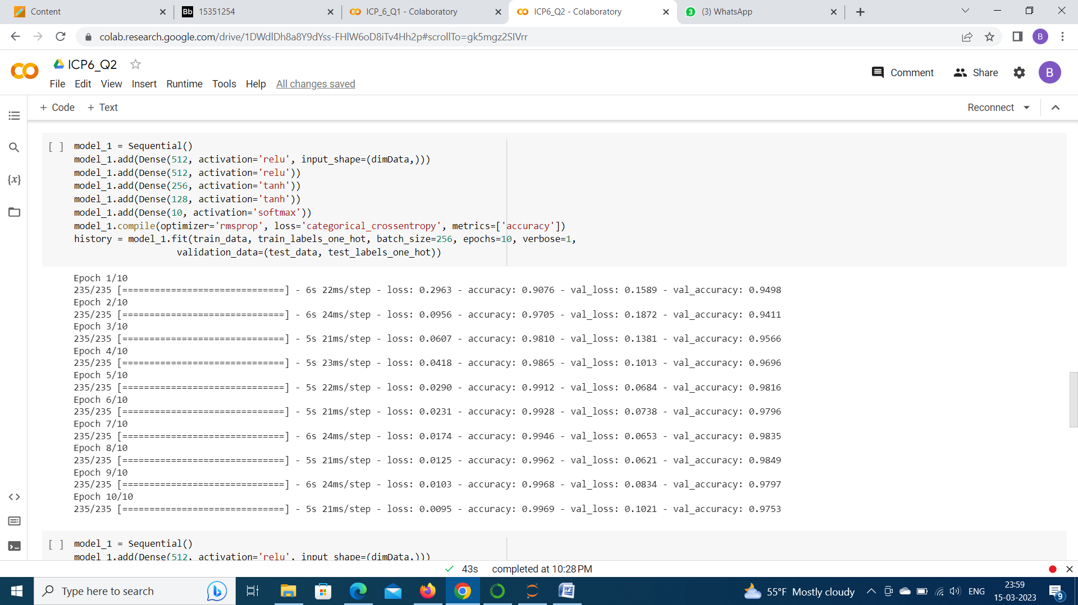

Observed the accuracy of the model for the different hidden layers.

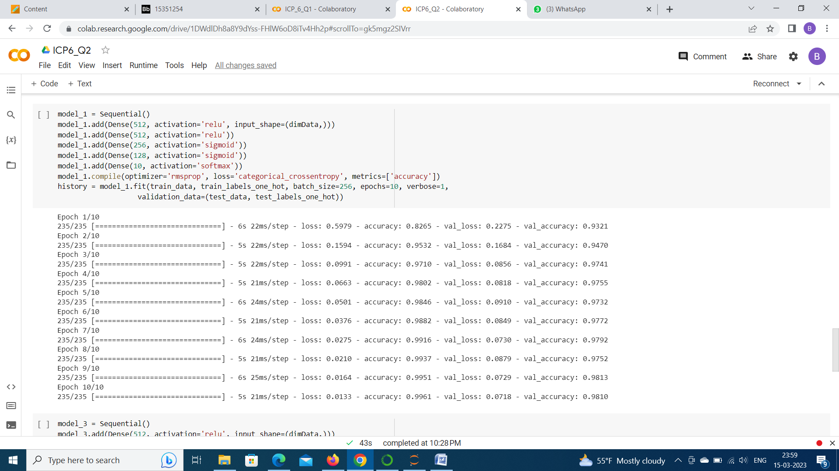

The data is given to the model without scaling the accuracy is decreased.